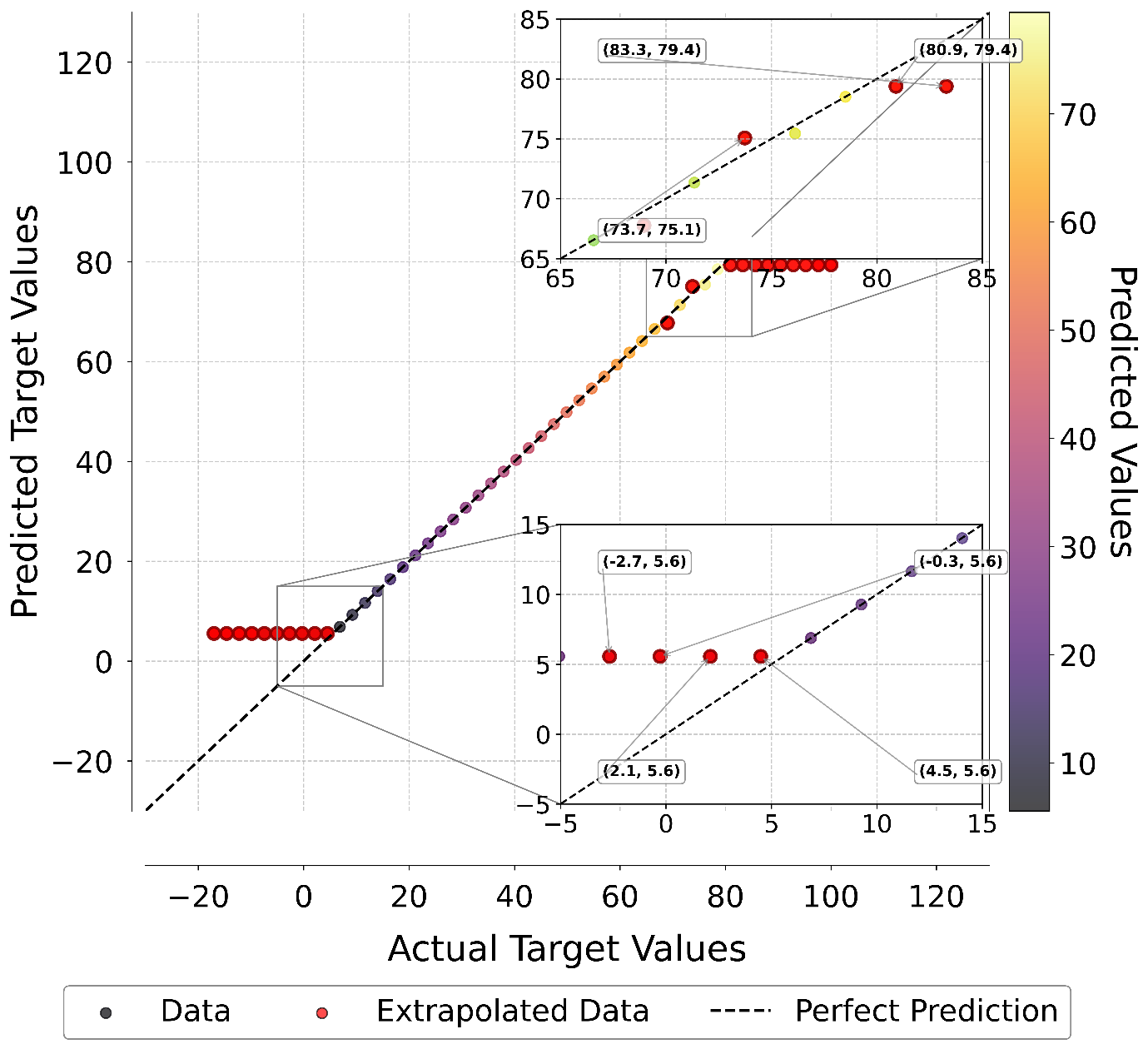Model performance analysis showing target vs predicted Tg values with extrapolation behavior. Red points indicate >1.0°C deviation from ideal prediction. Zoom boxes highlight low (-5 to 15°C) and high temperature (65 to 85°C) regions where systematic prediction errors occur outside the training range.

